**Lab 4**Q1 :

Q2:  
Q3:

Q4:  
Q5:  
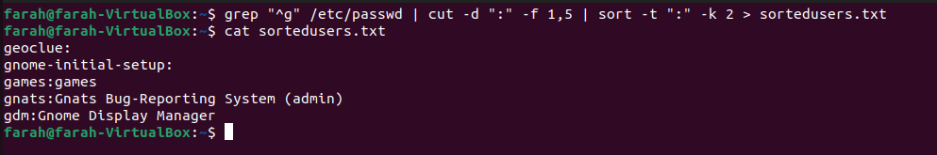  
Q6:  
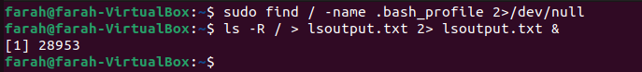  
Q7:  
Q8:

Q9:  
1.  
  
it displays the content of textfile.txt  
2.  
it runs the second command but filename is missing  
3.  
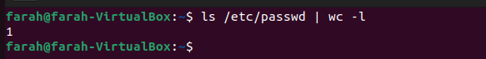  
it runs two commands but display result of second command  
Q10:

The command sleep 100 instructs the system to pause or sleep for 100 seconds. During this time, the command does nothing and simply waits for the specified duration before completing. This can be useful in various scenarios, such as delaying the execution of subsequent commands in a script or performing a time-based operation.

Q11:  
ctrl + c stops sleep command  
Q12:  
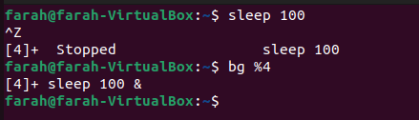

Q13:  
The jobs command displays the status of jobs started in the current shell environment. If no specific job is specified with the JobID parameter, status information for all active jobs is displayed. If a job termination is reported, the shell removes that job's process ID from the list of those known by the current shell environment.  
Q14:

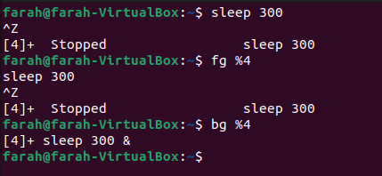

Q15:  
Q16:  
Q17:  
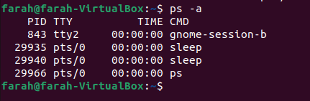  
Q18:  
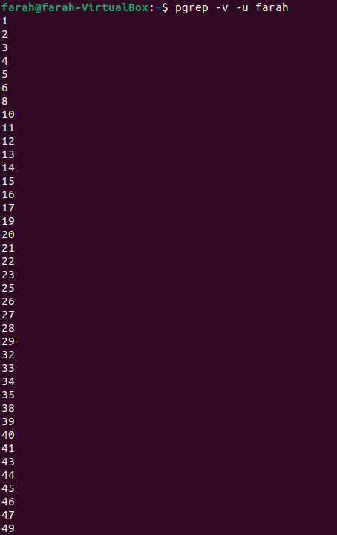  
Q19:  
  
this command make the user log out from the system, it kills all processes.